CYBERSECURITY INCIDENT MANAGEMENT

Business problem:-
Organizations face frequent cybersecurity incidents that can lead to financial loss, data breaches, and downtime. There is a need to track attack attempts, monitor affected systems and users, and measure the impact of incidents over time. This dataset provides actionable insights to analyse attack patterns, assess incident severity, and understand the consequences on company operations and users, enabling better-informed decisions to mitigate future risks.

Tools Used:-
This project integrates multiple technologies to ensure a complete data analytics workflow from raw data to business-ready insights.
Tool | Purpose | Key Usage
Excel | Data Preparation | Cleaned, filtered, and merged multiple CSV files; handled missing data and ensured consistency before loading into SQL.
SQL | Data Management & Analysis | Created relational tables, defined primary–foreign key relationships, and performed analytical queries (joins, aggregations, KPIs).
Power BI | Visualization & Insights | Designed five interactive dashboards — Incident, Attacker, Impact, Response, and User — to analyse attacks, impacts, and response performance.

Schema:-
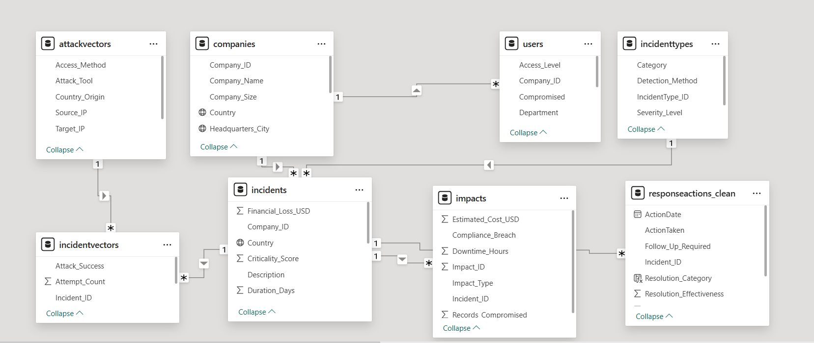

Dataset Info:-

Tables:-
- companies
- incidenttypes
- attackvectors
- incidents
- incidentvectors
- impacts
- responseactions
- users

Description
- Companies.csv
Column | Explanation
Company_ID | Primary key.
Company_Name | Official name of the company
Industry | Type of business the company operates in (IT, Finance, Healthcare, etc).
Company_Size | Company by number of employees:  Small, Medium & Large .
Revenue_USD | Annual revenue in USD.
Headquarters_City | City of main office
Country | Country where the company operates.
Is_Government_Org | Boolean (True/False).  True- indicates the organization is a government entity  False- indicates private sector.

- incidenttypes.csv
Column | Explanation
IncidentType_ID | Primary key.
Type_Name | Name of the attack type (Phishing, Malware, Ransomware, DDoS, etc)
Category | Classification of attack origin:  • Internal: Initiated from inside the organization, e.g., malicious insider, employee errors.  • External: Initiated from outside the organization, e.g., hackers, phishing campaigns, malware.
Severity_Level | Level of seriousness of the attack: Low, Medium, High, Critical.
Detection_Method | Method used to detect the incident (e.g., SIEM, IDS, Manual detection, Antivirus)

- attackvectors.csv
Column | Explanation
Vector_ID | Primary key.
VectorName | Medium of attack: Email, Network, Web Application, USB, API, etc
Source_IP | IP address from which the attack originated.
Target_IP | IP address of the system being attacked.
Country_Origin | Country where the attack originated
Access_Method | Method used to access the system: HTTP, SSH, RDP, USB, API, etc.
Attack_Tool | Specific tool or malware used (e.g., SQL map, Phishing Kit, Ransomware)

- incidents.csv
Column | Information Explanation
Incident_ID | Primary key.
Company_ID | Foreign key → companies.
IncidentType_ID | Foreign key → incidenttypes.
Reported_Date | Date when the incident was reported.
Resolved_Date | Date when incident was resolved.
Severity | Overall seriousness of the incident:  Low, Medium, High, Critical.
Status | Current stage of the incident:  Open, In Progress, Closed, Mitigated.
Description | Brief summary of the incident.
Financial_Loss_USD | Actual monetary loss due to the incident.
Criticality_Score | Numeric rating (1–10) showing impact severity. Higher values indicate higher business-critical risk.
IP_Address | Internal IP involved in the attack. Helps trace compromised systems.
Country | Country of the affected system. Useful for mapping and regional analysis.
Duration_Days | Total days taken to resolve the incident. Used to measure operational efficiency.

- incidentvectors.csv
Column | Information Explanation
IncidentVector_ID | Primary key.
Incident_ID | Foreign key → incidents.
Vector_ID | Foreign key → attackvectors.
Attack_Success | Boolean (True/False). Indicates whether the attack succeeded.
Attempt_Count | Number of times the attack was attempted.

- impacts.csv
Column | Explanation
Impact_ID | Primary key.
Incident_ID | Foreign key → incidents
Impact_Type | Type of damage: Data Loss, Financial Loss, Downtime, Reputation.
Downtime_Hours | Total hours system was unavailable due to incident
Records_Compromised | Number of sensitive records stolen or lost.
Compliance_Breach | Boolean (True/False). Indicates whether incident violated regulations (GDPR, HIPAA, etc.).
Estimated_Cost_USD | Estimated financial cost of the impact

- responseactions.csv

Column | Explanation
ResponseID | Primary key.
Incident_ID | Foreign key → incidents.
ActionTaken | Type of response performed:  Patch Applied, Account Locked, System Reboot, etc.
ResponsibleTeam | Team performing the action (IT, SOC, Legal, etc).
ActionDate | Date when action was taken.
Response_Time_Hours | Time taken to respond after detection.
Resolution_Effectiveness | Rating 1–10 for effectiveness of response
Follow_Up_Required | Boolean (True/False). Indicates whether further action was needed.

- users.csv
Column | Explanation
User_ID | Primary key.
Company_ID | Foreign key → companies.
UserName | Login or display name of user.
User_Role | Job role: Admin, Manager, Employee, etc.
Department | Department name (IT, HR, Security).
Access_Level | Privilege level: Low, Medium, High. Identifies sensitive accounts.
Is_Internal_User | Boolean (True/False). True = internal employee, False = outsider/external account.
Last_Login_IP | Last IP used to log in.
Compromised | Boolean (True/False). True if user account was compromised.

Dashboards:-
- Incident Dashboard
- Attacker's Dashboard
- Impact Dashboard-
- Response Dashboard
- User Dashboard

Insights:-
1. Incident Dashboard
Summary:
This dashboard shows incidents that happened
This dashboard provides an overview of all cybersecurity incidents — including frequency, type, severity, and resolution metrics.
Key Insights:
Total incidents: 42.44K, with most frequent IP 192.168.99.97.
Average resolution time: 274 hours.
25% of government organizations targeted
6.8% revenue loss.
Top incident types: Bar chart. Attack type-Zero-Day Exploit, Phishing, and Malware.
Most incidents are closed: Donut chart (30K), showing good resolution activity.
Incidents peaked in December: Line chart indicating seasonal trends or targeted campaigns.

2. Attacker’s Dashboard
Summary:
This dashboard shows attempts that made by attacker. There attacks success .
This dashboard focuses on attack sources, methods, and success rates to understand adversary behaviour.
Key Insights:
Active attacker IPs: showing high external threat activity.
Most targeted IPs: showing IP addresses of mot targeted victim
Main attack tools: bar chart. Botnets, Custom Malware, Exploits, Phishing Kits, SQL map.
Common attack vectors: Heat map. Social Engineering, USB Devices, Email, Web Applications.

3. Impact Dashboard
Summary:
Through incidents impact that made in loss, downtime hr, records compromised. Displays the financial, downtime, and compliance impacts of cybersecurity incidents.
Key Insights:
Total financial loss: ~$1.9B (↑9.24% from previous month).
Downtime: 1.11K hours; 741K records compromised.

4. Response Dashboard
Summary:
This dashboard show efficiently action taken for incidents
Monitors the organization’s incident response performance and effectiveness.
Key Insights:
86.62% of incidents had response actions taken.
Common actions: bar chart Legal notification, Backup restoration, Patching.
Response effectiveness: pie chart37% medium, 31% high, 31% low.
Teams involved: pie chart Management (80), SOC (79), Legal (75).
Side by side bar chart- SOC and Legal teams have similar response and downtime durations (~116 hrs).
donut chart -67% of cases didn’t require follow-up

5. User Dashboard
Summary:
This dashboard shows users that company compromise through attack
Tracks user-related cybersecurity exposure, focusing on compromised accounts and access levels.
Key Insights:
50K total users, 24.82% compromised (≈12.4K users).
4,194 high-access users compromised, posing significant risk.
Internal users: 37.32K vs External: 13K.
Visual type-Table:
Compromises are mainly among Finance and IT departments.
High-risk internal users in government and education sectors highlight insider vulnerability.

